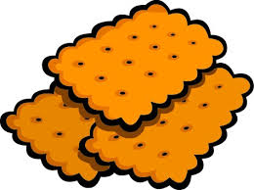 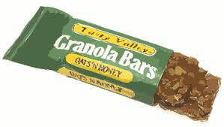 SNACK TIME 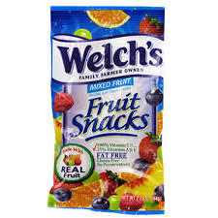
This year in Kindergarten, we will be eating lunch at 12:10 p.m. This can be quite a long time between breakfast and lunch. The Kindergarten staff has planned a time each morning that your child can eat a small snack and then get a drink from the water fountain.
Starting on Tuesday, August 22nd, your child will need to bring his/her own snack for each day. There are multiple options for how to send in snacks for your child:
**You can do this daily (in a snack-sized baggie or pre-packaged snack item).
**You can send in a gallon-sized baggie with 5 snacks (one week’s worth) and your child can choose from one of those choices.
** You can send in a gallon-sized baggie with a variety of treats (10-15 choices)(bags of fruit snacks, small bags of crackers or cookies, or snack-sized baggies with food inside) and your child can choose from those treats.
**You can send in 2 boxes of snacks items and your child will choose between these 2 choices daily until these snacks are gone. (Regular sized boxes/bags…not mega-sized boxes/bags due to storage issues.)
If you choose to send a bag of snack options or 2 boxes of snack items, I will send home a note when your child is close to being out of snack items.
Please ask if you have any questions.
The Kindergarten Staff

