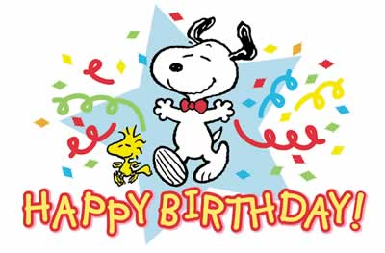
BIRTHDAY TREATS
As a grade level, we have decided to ask that full-size cupcakes not be sent in for birthdays. The large size cupcakes rarely get eaten-mostly the frosting is licked off and that’s all. It’s a lot of sugar for little tummies.
Awesome options are:
**Small cupcakes (1 or 2 per child).
**Cookies are always a big crowd pleaser.
**Wrapped treats like Little Debbie or Hostess snacks.
**Small bags of pretzels or popcorn or chips.
**Popsicles or an ice cream treat.
All birthday treats must be store/bakery bought.
You may send in drink pouches if you would like along with your child’s birthday treat.
Thank you for your cooperation!
The Kindergarten Teachers
P.S.: In our room, we usually have birthday treats as our snack for the day.

We do not have any allergies in our room this year.

